

**Introducing Generative AI with AWS**

**Project: Building a Domain Expert Model**

# **Environment and Project Setup**

**Configured and completed the below steps and used Aws US West Oregon (us-west-2) Region.**

* An AWS SageMaker IAM Role
* An AWS SageMaker Notebook Instance
* A GPU instance for fine-tuning training
* Downloaded the [**project starter files**](https://video.udacity-data.com/topher/2024/February/65bb2743_genaiwithawsprojectstarter/genaiwithawsprojectstarter.zip).

**Step 1: Upload Project Starter Files**

* **Creating and Running the Fine-tuningProject Instance**

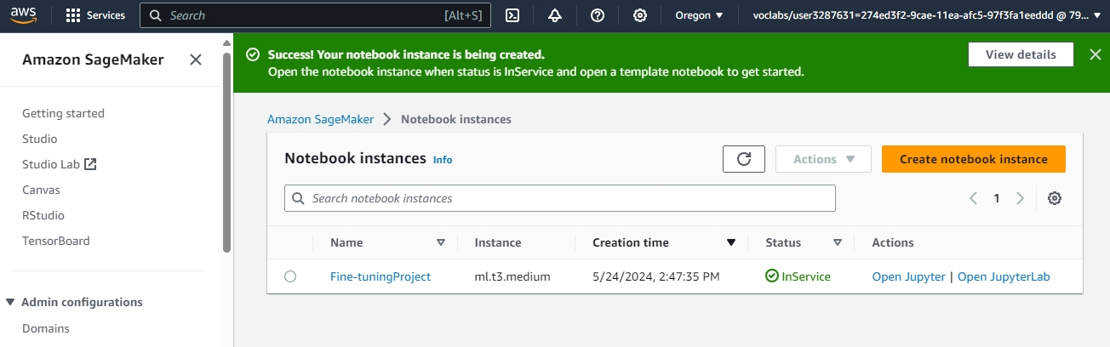

* **Uploading the Python notebook files (.ipynb)**

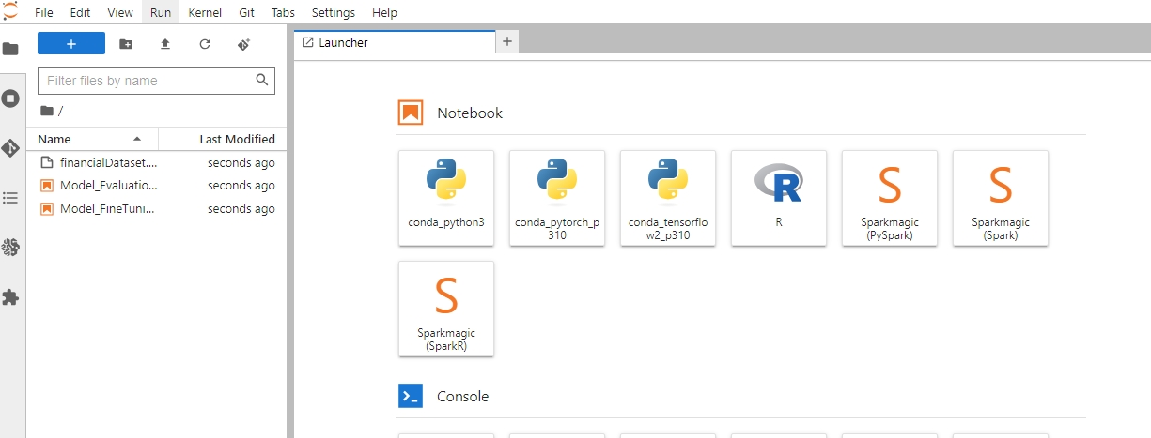

**Step 2: Choose your Dataset**

I have opted for a dataset within the domain of **Financial Domain**.

**Step 3: Deploy and Evaluate the model (Model_Evaluation.ipynb)**

* Completed and ran the cells in the Model_Evaluation.ipynb file
* Screenshot of the Model Deployment of Model_Evaluation.ipynb

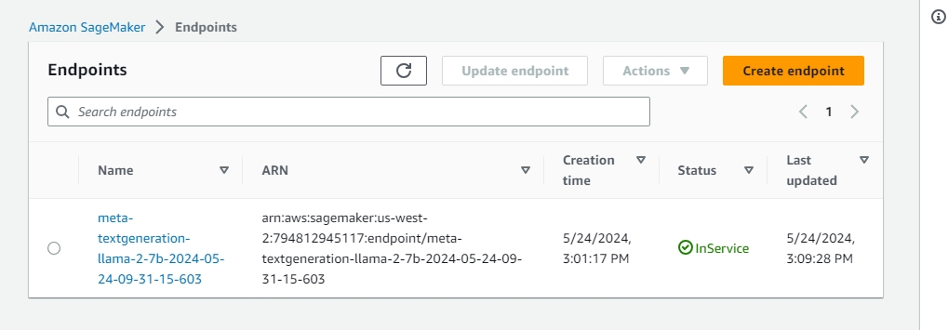

* Saved and download Model_Evaluation.ipynb with the cell output,uploaded in the zip file and file name is ***Model_Evaluation_UdacityGenAIAWS.ipynb***
* Screenshot of the Model_Evaluation.ipynb file with the cell output as proof

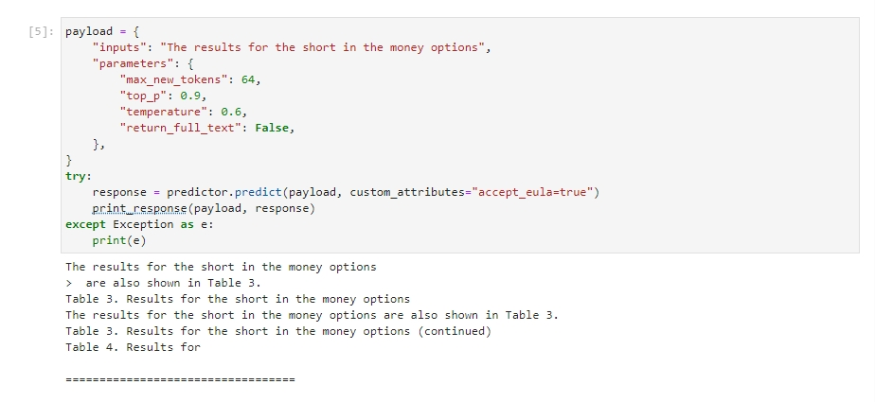

* Screenshot of Deleted the Model Deployment and endpoints

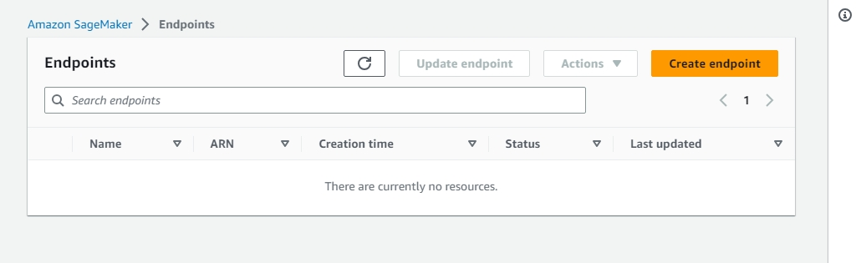

* Updated the Project Documentation section about the evaluation of the model's text generation capabilities and knowledge.

**Step 4: Fine-tune the Model (Model_FineTuning.ipynb)**

* Completed and ran the cells in the Model_FineTuning.ipynb
* Saved and download Model_Evaluation.ipynb with the cell output,uploaded in the zip file and file name is ***Model_FineTuning.ipynb***
* screenshot of the Model_FineTuning.ipynb file with the cell output as proof

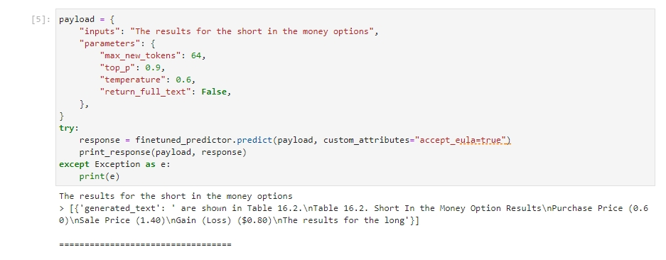

* Updated the Project Documentation Report section about fine-tuning the model

**Step 5: Deploy and Evaluate the Fine-tuned Model**

* Screenshot of Visiting the AWS S3 bucket where my fine-tuned model weights are stored after training for your submission.

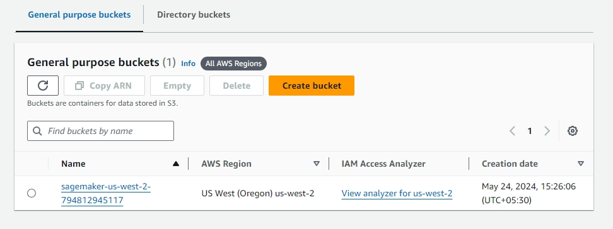

**ARN -** arn:aws:s3:::sagemaker-us-west-2-794812945117

* Screenshot of Model_FineTuning.ipynb file about deploying and evaluating the fine-tuned model.

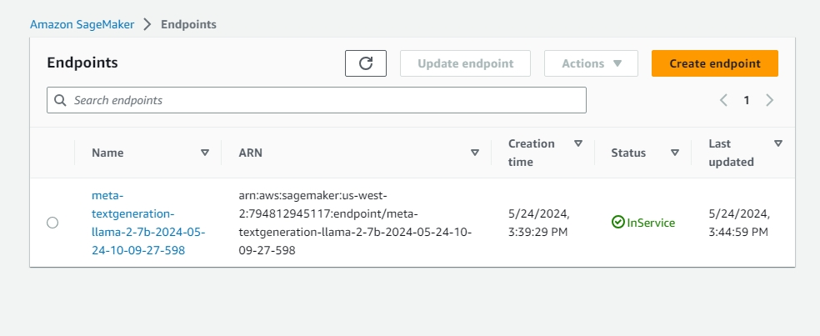

* Screenshot of the Model_FineTuning.ipynb file with the cell output as proof



* Screenshot of Deleted the Model Deployment and endpoints(Cell Output)

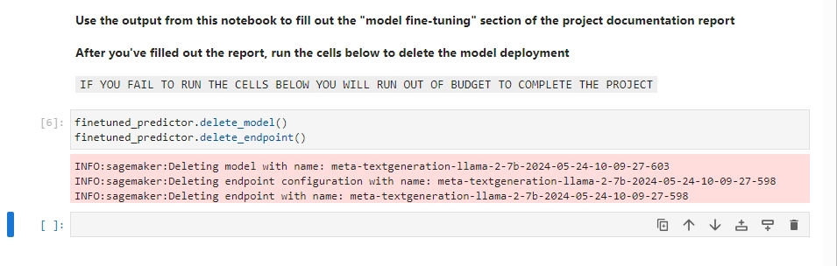

* Screenshot of Deleted the Model Deployment and endpoints(Cell Output)

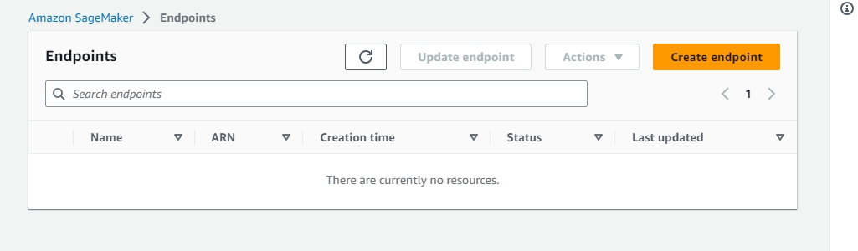

* Updated the Project Documentation Report section about fine-tuning the model.

**Step 6: Collect Project Documentation and Submit**

**Zip File Named Project_Building_a_Domain_Expert_Model.zip is uploaded and consists of**

* Model_evaluation.ipynb with cell output (File_Name:-Model_evaluation.ipynb).
* Model_FineTuning.ipynb with cell output (File_Name:- Model_FineTuning.ipynb).
* Screenshots of both notebooks with cell output.
* The completed Project Documentation Report (File_Name:- UDACITY Introduction to Generative AI with AWS Project Documentation Report).
* Snapshots folder consists of both the notebooks with outputs for better visibility.